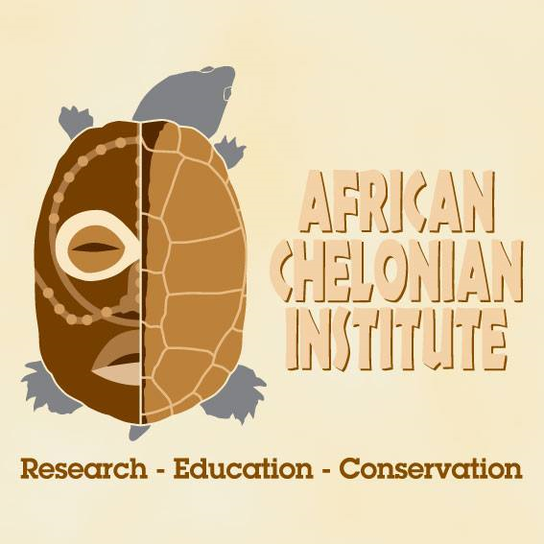
African Scholarship Program
Office: Villa Olivier, Ngazobil, Senegal
Tel: +221 77 950 0957
Email: africanci@gmail.com
Facebook: www.facebook.com/africanchelonianinstitute

APPLICATION FORM FOR AFRICAN SCHOLARSHIP PROGRAM TURTLE AND TORTOISE TRAINING COURSE 2021

BEFORE YOU APPLY: Please make sure you have read the course information sheet and fully understand the eligibility requirements specified below. Please prepare a .pdf version of your updated CV as you will be asked to attach this with your application. This program will only be able to support up to 12 participants meaning that the application process will be competitive and only thorough applications will receive consideration.
Deadline: 30th August 2021
Applicants can use the following option to submit their application:
- Email filled application form and supporting CV to email address africanci@gmail.com and pmcgovern@africanchelonian.org.
Eligibility Requirements:
Must have 2+ years of wildlife conservation related experience (preference given to applicants currently focused on chelonian conservation); university faculty not eligible
Must currently reside and work in one of the following West African countries: Nigeria, Benin, Togo, Ghana, Cote d’Ivoire, Liberia, Sierra Leone, Guinea, Guinea-Bissau, The Gambia, Senegal
Be available for the African Scholarship Program between 25 November – 05 December 2021
Be able to provide 2 reference contacts to vouch on your behalf

PERSONAL INFORMATION
Full Name:
Gender: ☐Female ☐Male | Date of Birth (DD/MM/YYYY):
Ethnicity:
Country of Origin:
Country of Residence:
Affiliated Organization and Position:
Phone number:
Facebook username (if any):
EDUCATION BACKGROUND
Summarize educational background (highest degree earned)
Department | University/School | Dates attended (from…to) | Degree(s) obtained
EMPLOYMENT HISTORY
Summarize your previous employments following structure below:
Period (from…to) | Title | Employer | Job description
WORKING/ RESEARCH EXPERIENCE
Summarize your work experience and research regarding biology and environment related to the chelonians. Please provide specific information, such as the title of research, year conducted, your role, and supervisors (if any).
PERSONAL STATEMENT
Why do you want to attend this training course? (up to 250 words)

What do you expect to gain from the training course? (up to 250 words)

After the course, how do you hope and plan to contribute to the research and conservation of tortoise and turtles and other wildlife in West Africa? (up to 250 words)

REFERENCES
References are people who can speak to your passion and work ethic for conservation
Reference 1
Full name: | Title:
Position: | Workplace:
Email: | Phone number:
Reference 2
Full name: | Title:
Position: | Workplace:
Email: | Phone number:

We look forward to hosting you in Senegal for the 1st African Scholarship Program

